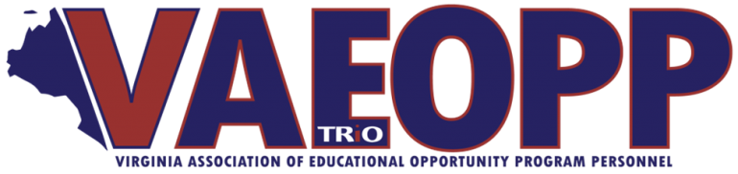
Board of Directors

President
Charlotte Mowery – Director
Wytheville Community College
Student Support Services

President – Elect
Sarah Williams – Director
Lord Fairfax Community College
Student Support Services

Past – President
Jessica Ketron – Director
Mountain Empire Community College
TRIO Programs – SSS and TS

Secretary
Carol Conner – Retention Specialist
Dabney S. Lancaster Community College
Student Support Services

Assistant Secretary
Kemper Edwards – Counselor
Mountain Empire Community College
Student Support Services

Treasurer
Adam Moore – Assistant Director
UVA at Wise
Upward Bound

Assistant Treasurer
Maria Whited – Counselor
Wytheville Community College
Student Support Services

Program Representatives

Educational Opportunity Center
Sharon Harris – Director
Danville Community College

Student Support Services
Dr. Mike Henry – Director
Southwest Virginia Community College

Upward Bound
Elizabeth Honaker – Counselor Southwest Virginia Community College

Talent Search
Tiffany Frierson – Counselor
Virginia State University

McNair
Michelle Pritchett – Academic Coordinator
Hampton University
Date: February 15, 2019

Name: Mike Henry

Title: SSS Program Representative

Activities:
Announcement 1: Student Support Services is celebrating its 50th Anniversary this year. As part of the celebration, COE held a SSS 50 Student Video Competition--with the winners featured at COE's 37th Annual Conference in New York City in September.

COE received 36 total entries, which were scored by the Communications Committee of COE’s Board of Directors on elements like creativity and production quality. The top five finalists, were (1) California State University-Dominguez Hills — veterans, (2) California State University-Long Beach, (3) Eastern Oklahoma State College, (4) Miami Dade College-Homestead Campus, and (5) Texas Christian University.

COE shared some ideas for ways to celebrate the 50th Anniversary, logos, noteworthy SSS alumni, and more, go to this URL for more information.
http://www.coenet.org/sss_50th_anniversary.shtml

COE will be conducting an Innovation forum In San Diego, CA on 4/15/19 and SSS Proposal Writing Workshop 4/16/19 also conducting another SSS proposal Writing workshop 7/19/19 in New York.

VAEOPP conducting a post conference for SSS on “Investigation Discovery and Section by Section Review” October 17th-18th.

The go live date for the SSS APR was January 22 , 2019 and Due date is March 8, 2019.

All SSS programs that received a 4.25% increase for 2018-19 !!! Congressman Griffith wrote a letter to Sec. DeVos on VA’s behalf

It’s our turn to write once again! Tentative date late Fall 2019.

